**Lab#2**

**Objective:** To illustrate and hands-on Copy Constructor and Destructor.

**Constructor**: A function that is called automatically when an object is created is called as constructor

**Default constructor**: A constructor that has no argument is a default constructor.

**Use of default constructor**: It is a constructor that does not accept any parameters. If there is no user-defined constructor for a class, the compiler declares a default parameter less constructor called default constructor. When the compiler uses this constructor to create an object – the constructor will have no constructor initializer and a null body.

**Lab Tasks:**

* Write below given code, compile it and run it.
* Write output of code in below given box.
* Write another program (C++ CODE) that uses parameterized and default Constructors to initialize the objects.
* Compile, run and write the output..

#include <iostream>

using namespace std;

class perimeter

{

private:

int l,b,peri;

public:

perimeter() //default constructor

{

cout<<"\nEnter the values of l and b"<<endl;

cin>>l>>b;

}

perimeter(int a) //Parameterized constructor with single parameter

{

l=b=a;

}

perimeter(int l1, int b1) //Parameterized constructor with two parameters

{

l=l1;

b=b1;

}

void calculate() //function to calculate the perimeter

{

peri=2*(l+b);

cout<<peri;

}

};

int main ()

{

perimeter obj1, obj2(3), obj3(2,3);

cout<<"\nPerimeter of Rectangle is "; obj1.calculate();

cout<<"\nperimeter of Square is "; obj2.calculate();

cout<<"\nPerimeter of Rectangle is "; obj3.calculate();

return 0;

}

**OUTPUT:**

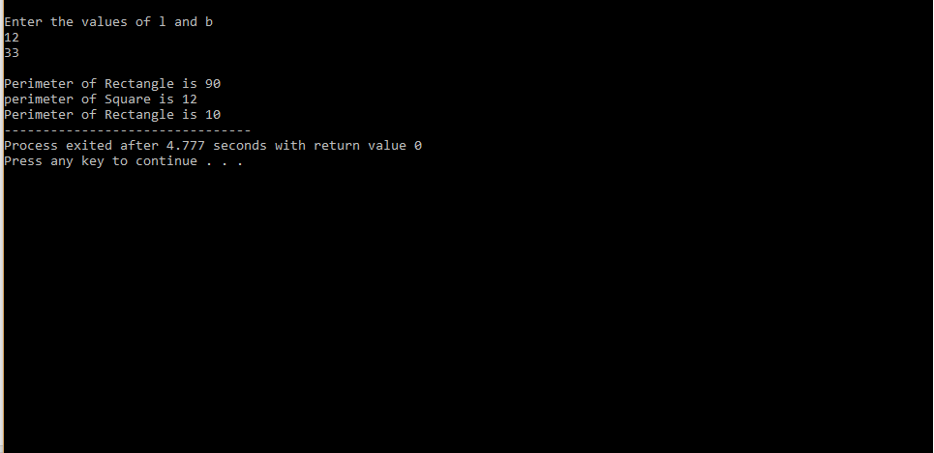

**2nd programme of this lab:**

#include<iostream>

using namespace std;

class Book

{

private:

int pg, price;

char title [50];

public:

void input ()

{

cout<<"Enter pages of book"<<endl;

cin>>pg.;

cout<<"Enter price of book"<<endl;

cin>>price;

cout<<"Enter Total of Book"<<endl;

cin>>title;

}

void show ()

{

cout<<"Title="<<title<<endl;

cout<<"Pages="<<pg.<<endl;

cout<<"Price="<<price<<endl;

}

};

int main ()

{

Book b1;

b1. input ();

Book b2(b1) ;//this is copy constructor

Book b3=b1;//this is also a copy constructor

cout<<"The details of b1 is"<<endl;

b1. show ();

cout<<"The details of b2 is"<<endl;

b2. show ();

cout<<"The details of b3 is"<<endl;

b2. show ();

}

**OUTPUT:**

